**Practical 10 Study of Network Commands in Windows and Linux.**

* **Ipconfig** :- Ipconfig is a Console Command which can be issued to the Command Line Interpreter (or command prompt) to display the network settings currently assigned to any or all network adapters in the machine.
  + This command can be utilised to verify a network connection as well as to verify your network settings.

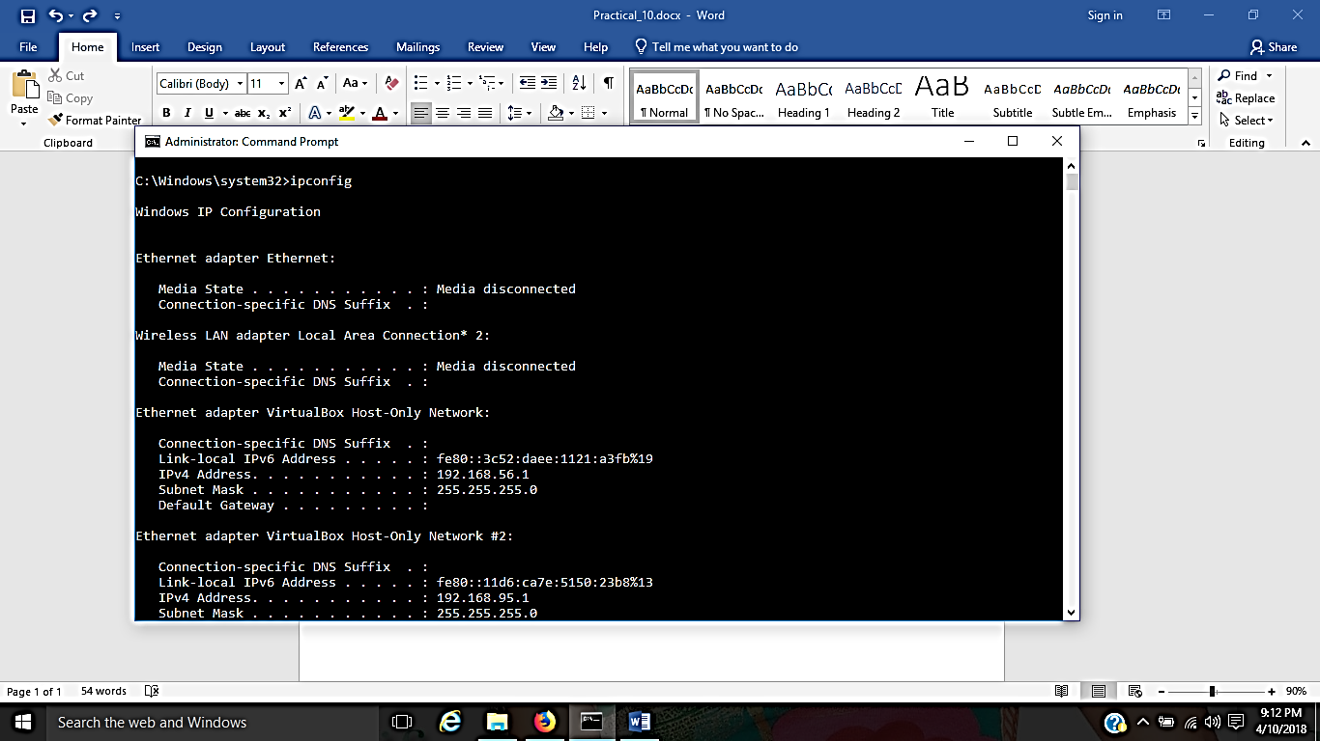

* **Netstat :- Displays active TCP connections, ports on which the computer is listening, Ethernet statistics, the IP routing table, IPv4 statistics (for the IP, ICMP, TCP, and UDP protocols), and IPv6 statistics (for the IPv6, ICMPv6, TCP over IPv6, and UDP over IPv6 protocols).** 
  + **Used without parameters, netstat displays active TCP connections.**

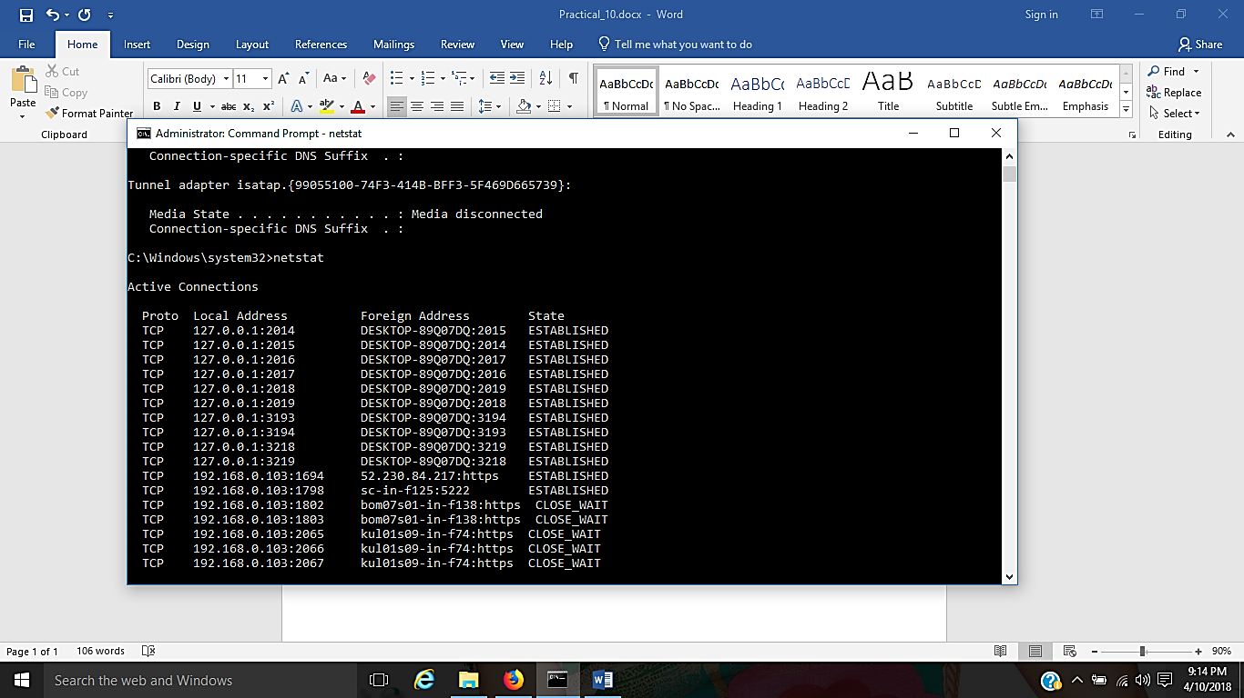

* **Tracert :- The tracert command is used to visually see a network packet being sent and received and the amount of hops required for that packet to get to its destination.**

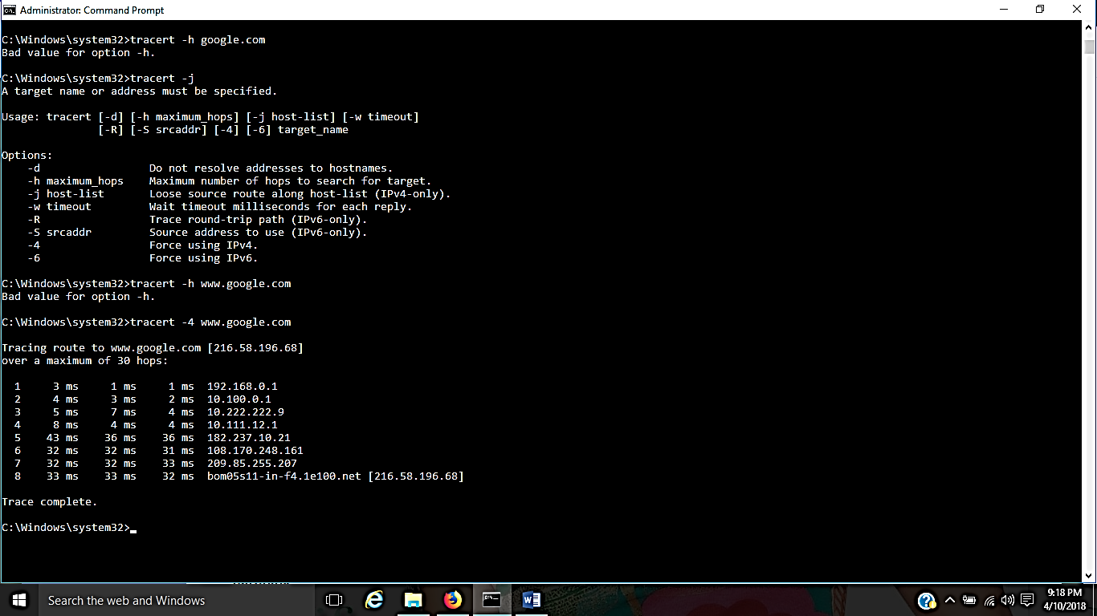

* **Ping :- Helps in determining TCP/IP Networks IP address as well as determine issues with the network and assists in resolving them.**

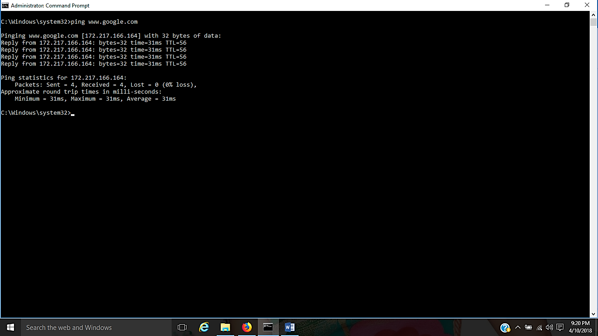

* **Pathping :- Provides information about network latency and network loss at intermediate hops between a source and destination.** 
  + **Pathping sends multiple Echo Request messages to each router between a source and destination over a period of time and then computes results based on the packets returned from each router.**

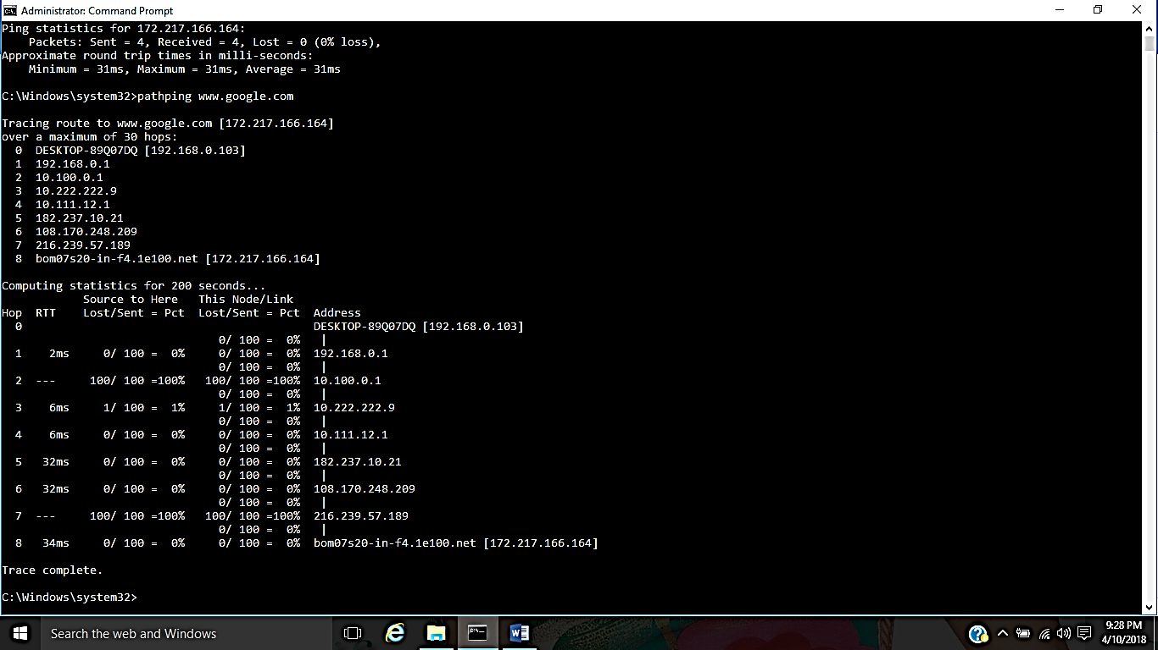

* **telnet :- Telnet is software that allows users to remotely access another computer such as a server, network device, or other computer.** 
  + **With telnet users can connect to a device or computer, manage a network device, setup a device, transfer files, etc.**
* **ftp :- FTP is short for File Transfer Protocol, this page contains additional information about the FTP command and help using that command in Unix and MS-DOS (Windows).**
* **Route :- The function and syntax of the Windows ROUTE command is similar to the UNIX or Linux route command. Use the command to manually configure the routes in the routing table.**

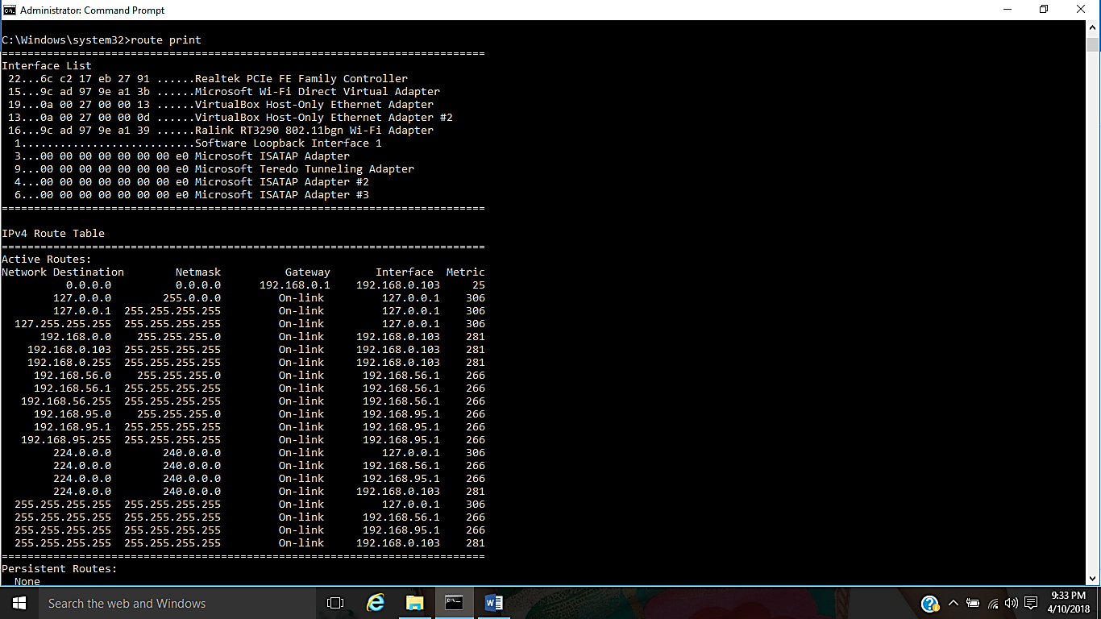

* **Arp :- Displays, adds, and removes arp information from network devices.**

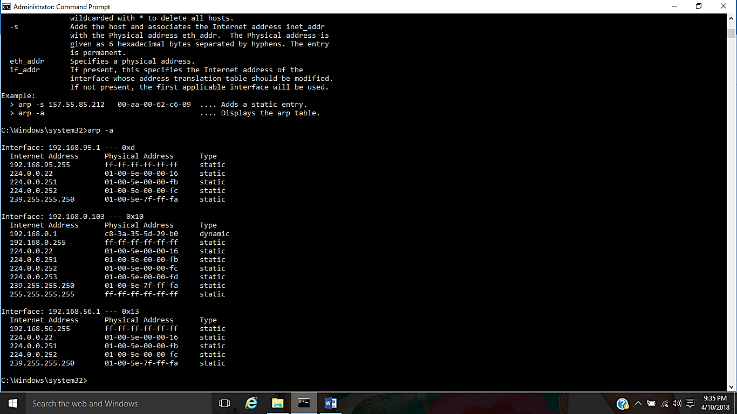

* **Nslookup** :- Displays information that you can use to diagnose Domain Name System (DNS) infrastructure.

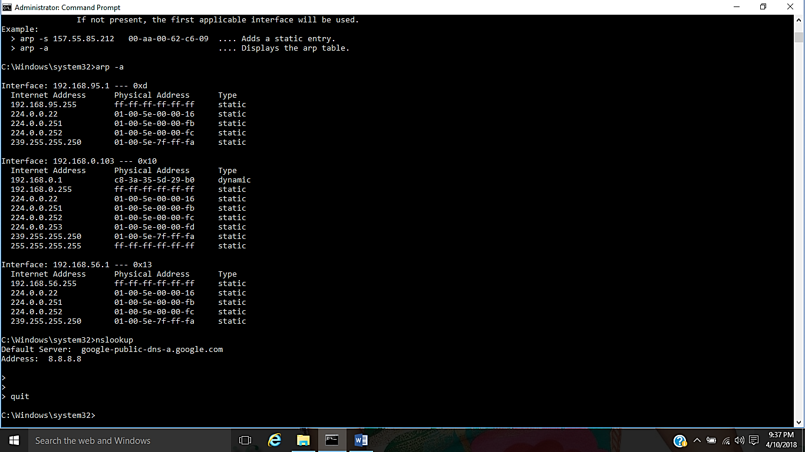

* **Nbtstat** :- MS-DOS utility that displays protocol statistics and current TCP/IP connections using NBT.

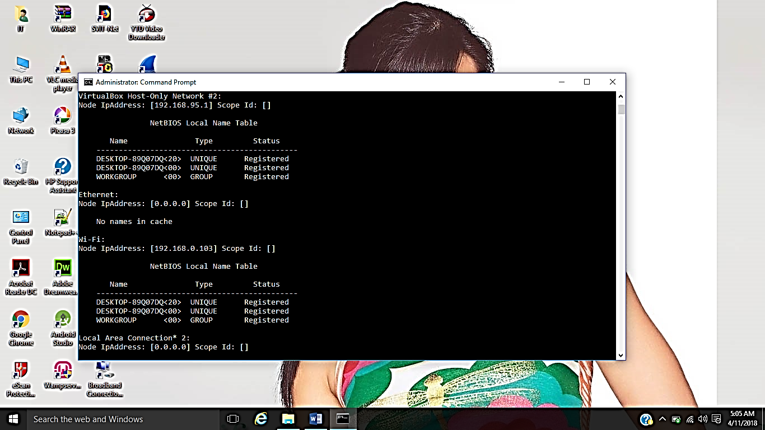

* **Getmac** :- DOS command used to show both local and remote MAC addresses.
  + When run with no parameters (ie. getmac) it displays MAC addresses for the local system.
  + When run with the /s parameter (eg. getmac /s \\foo) it displays MAC addresses for the remote computer. When the /v parameter is used, it also displays the associated connection name and network adapter name.

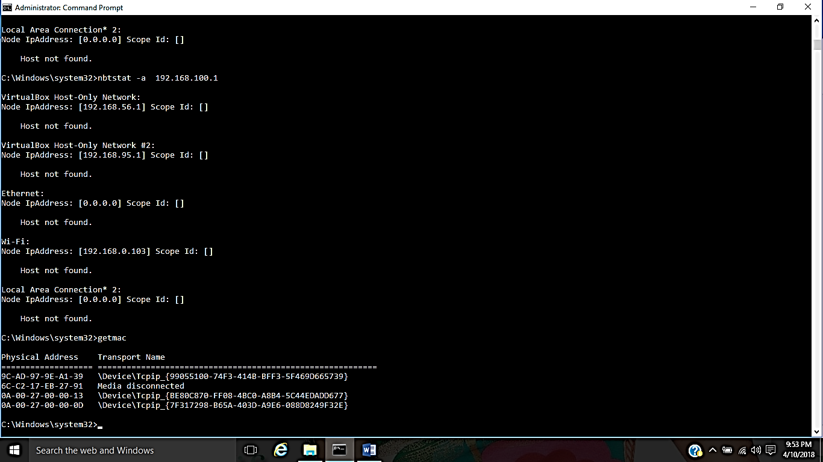

ipconfig  
Ipconfig is a Console Command which can be issued to the Command Line Interpreter (or command prompt) to display the network settings currently assigned to any or all network adapters in the machine. This command can be utilised to verify a network connection as well as to verify your network settings

netstat  
Displays active TCP connections, ports on which the computer is listening, Ethernet statistics, the IP routing table, IPv4 statistics (for the IP, ICMP, TCP, and UDP protocols), and IPv6 statistics (for the IPv6, ICMPv6, TCP over IPv6, and UDP over IPv6 protocols). Used without parameters, netstat displays active TCP connections.

tracert  
The tracert command is used to visually see a network packet being sent and received and the amount of hops required for that packet to get to its destination.

[ping](http://whirlpool.net.au/wiki/ping)  
Helps in determining TCP/IP Networks IP address as well as determine issues with the network and assists in resolving them.

pathping  
Provides information about network latency and network loss at intermediate hops between a source and destination. Pathping sends multiple Echo Request messages to each router between a source and destination over a period of time and then computes results based on the packets returned from each router.

telnet  
Telnet is software that allows users to remotely access another computer such as a server, network device, or other computer. With telnet users can connect to a device or computer, manage a network device, setup a device, transfer files, etc.

ftp  
FTP is short for File Transfer Protocol, this page contains additional information about the FTP command and help using that command in Unix and MS-DOS (Windows).

route  
The function and syntax of the Windows ROUTE command is similar to the UNIX or Linux route command. Use the command to manually configure the routes in the routing table.

arp  
Displays, adds, and removes arp information from network devices.

nslookup  
Displays information that you can use to diagnose Domain Name System (DNS) infrastructure. Before using this tool, you should be familiar with how DNS works. The Nslookup command-line tool is available only if you have installed the TCP/IP protocol.

nbtstat  
MS-DOS utility that displays protocol statistics and current TCP/IP connections using NBT.

getmac

DOS command used to show both local and remote MAC addresses. When run with no parameters (ie. getmac) it displays MAC addresses for the local system. When run with the /s parameter (eg. getmac /s \\foo) it displays MAC addresses for the remote computer. When the /v parameter is used, it also displays the associated connection name and network adapter name.

Ifconfig

ifconfig utility is used to configure network interface parameters.Mostly we use this command to check the IP address assigned to the system.

## dig

dig (Domain Information Groper) is a flexible tool for interrogating DNS name servers.

## telnet

telnet connect destination host:port via a telnet protocol if connection establishes means connectivity between two hosts is working fine. nslookup is a program to query Internet domain name servers.

## netstat

[Netstat](https://geekflare.com/netstat/)command allows you a simple way to review each of your network connections andopen sockets.

## scp

scp allows you to secure copy files to and from another host in the network.

## w

w prints a summary of the current activity on the system, including what each user is doing, and their processes.

nmap

nmap is a one of the powerful commands, which checks the [opened port](https://geekflare.com/port-scanner-server/) on the server.

## Enable/Disable Network Interface

You can enable or disable the network interface by using ifup/ifdown commands with ethernet interface parameter.